1. **Create Feature File**
2. **Documentation:** [**https://confluence.global.standardchartered.com/pages/viewpage.action?spaceKey=IFRS9&title=Feature+File+Auto+Creator**](https://confluence.global.standardchartered.com/pages/viewpage.action?spaceKey=IFRS9&title=Feature+File+Auto+Creator)
3. **Test Case Template:**
   1. Prepare your test case using the template attached.
   2. Fill in columns highlighted in yellow.
   3. Fill in columns highlighted in orange (optional).
   4. Do not change the columns as the tool will only refer to the columns in the template.
   5. Each tab corresponding to 1 feature file. (Tab name = Feature file name)
   6. Leave the “Index” tab as it is.



1. **Tool:**
   1. Copy this tool to your local



* 1. Enable macro
  2. Enter the test case file path (created at (A).item (2))
  3. Enter the output folder path for the gherkin script.
  4. Click “Create Feature”.

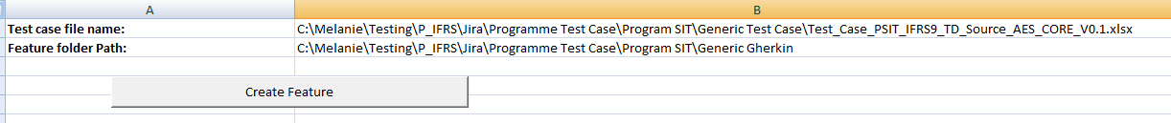

* 1. Feature file successfully created:

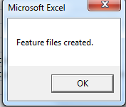

* 1. Go to the output folder, delete the “Index.feature”.

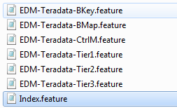

1. **Jira Task Creator:**
2. **Documentation:**

[**https://confluence.global.standardchartered.com/display/IFRS9/JIRA+Tasks+Auto+Creator**](https://confluence.global.standardchartered.com/display/IFRS9/JIRA+Tasks+Auto+Creator)

1. **Tool link:** [**http://teamsites.sc.com/sites/ifrs9/Shared%20Documents/Forms/AllItems.aspx?RootFolder=%2Fsites%2Fifrs9%2FShared%20Documents%2F14%2E%20Systems%20and%20Technology%2F06%20%2D%20System%20Test%2FTest%20Tools%2FJira%20Task%20Creator%20From%20Feature%20File&FolderCTID=0x0120004213B70B9FF5074590E3C548785A7880&View=%7B2C821DE7%2D2C53%2D4BB5%2D9395%2DE1F2EF078D2A%7D**](http://teamsites.sc.com/sites/ifrs9/Shared%20Documents/Forms/AllItems.aspx?RootFolder=%2Fsites%2Fifrs9%2FShared%20Documents%2F14%2E%20Systems%20and%20Technology%2F06%20%2D%20System%20Test%2FTest%20Tools%2FJira%20Task%20Creator%20From%20Feature%20File&FolderCTID=0x0120004213B70B9FF5074590E3C548785A7880&View=%7B2C821DE7%2D2C53%2D4BB5%2D9395%2DE1F2EF078D2A%7D)
2. Download the tool to your local and follow the steps in (1).
3. Edit the config.properties (yellow highlighted):

Note:

*Make sure your laptop is installed with **Java version 1.6** and higher. You can check via cmd: java -version

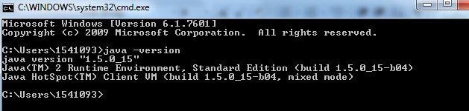

*Make sure the features file folder contains all the feature files that you need to link to the user story (A.3.d).

* Feature files folder path is with “/” instead of “\”.

*Remember to delete the Index.feature in the folder

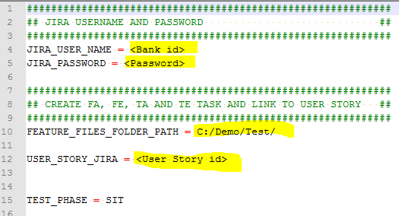

1. Double click “JiraCreater.bat”
2. Check in JIRA using the user story id, successful creation will have the TE created and link to the user story:

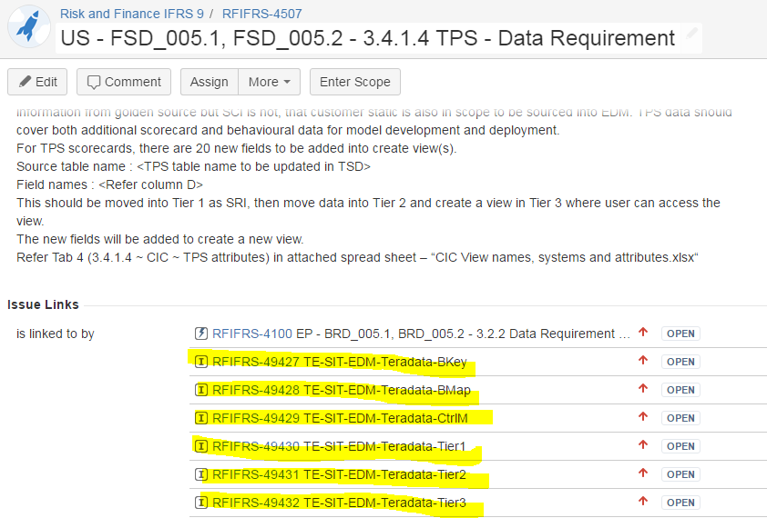

1. **Upload Feature File to Stash Repository**
2. **Documentation:**
   1. JIRA E2E Approach & Implementation document : <https://confluence.global.standardchartered.com/pages/viewpage.action?pageId=74495656>

This is an overview of how JIRA is used in IFRS9. Note there are some of the item already obsolete but still is a good reference for a start.

* + 1. Refer to the section “STASH”
    2. IFRS9-Stash Step by Step Instructions – Using IntelliJ.

<https://confluence.global.standardchartered.com/display/IFRS9/IFRS9-Stash+Step+by+Step+Instructions>

1. Alternatively you can use “GIT GUI” or “GIT CMD” for easy upload to stash Repository:

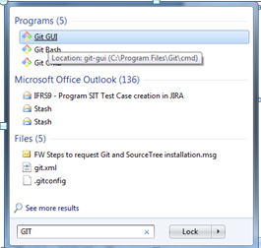

1. Stash Repository for IFRS9 : [**https://bitbucket.global.standardchartered.com/projects/IFRS9**](https://bitbucket.global.standardchartered.com/projects/IFRS9)

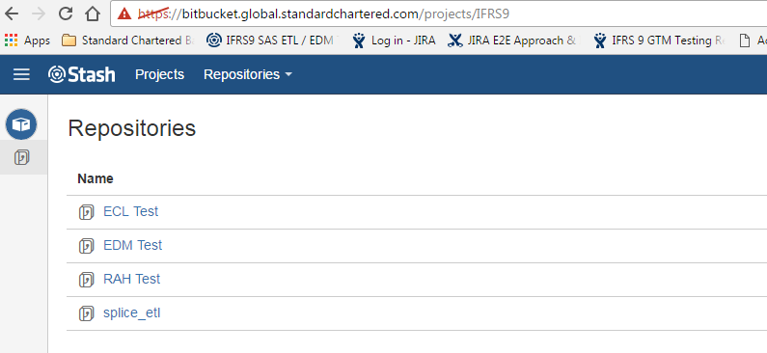

1. Please send email to (Pavithran, Soji, 1540818) to get the repository access.
2. Go to the respective repository, for example **EDM Test**, you can see the feature files uploaded to the Stash repository.

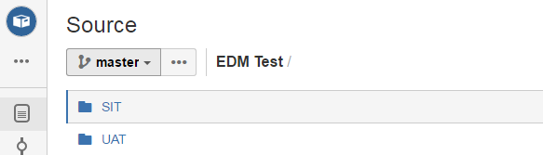

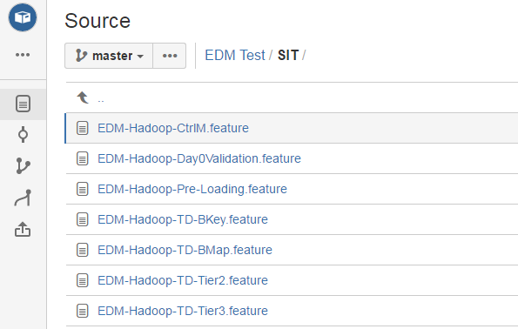

1. For first time user, you need to clone the server repository to your local.

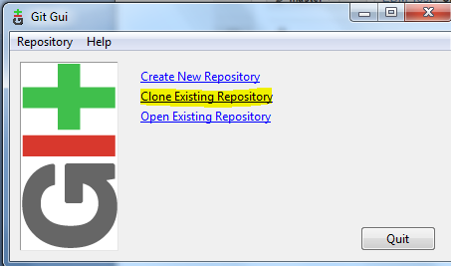

1. For first time user, you need to clone the server repository to your local.
   1. **Source Location**: <http://1541093@stash.uk.standardchartered.com:7990/scm/ifrs9/edm-test.git>
      1. Please change the bank id to your own bank id.
   2. **Target Directory**: Your local directory, just type the new folder name, does not required to create the folder first. Example: C:\IFRS9 Test.
   3. Click Clone.
   4. It will prompt for password 3 times (your windows password)

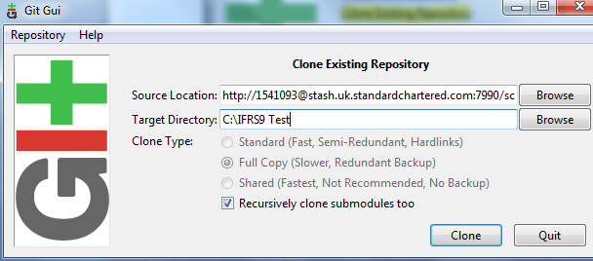

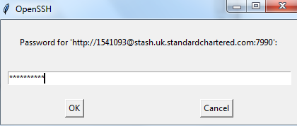

1. After successful cloning, check your local directory, the feature files is downloaded to your local directory. 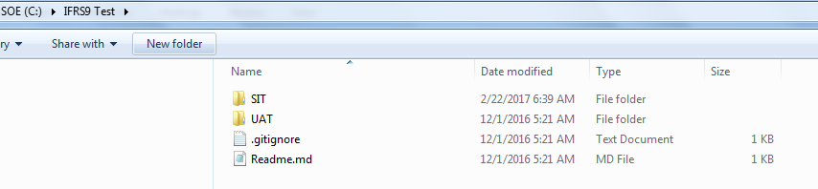
2. To upload the created feature files in Section (A.3) above, copy the feature files to the Stash repository in your local. For example: C:\IFRS9 Test\SIT

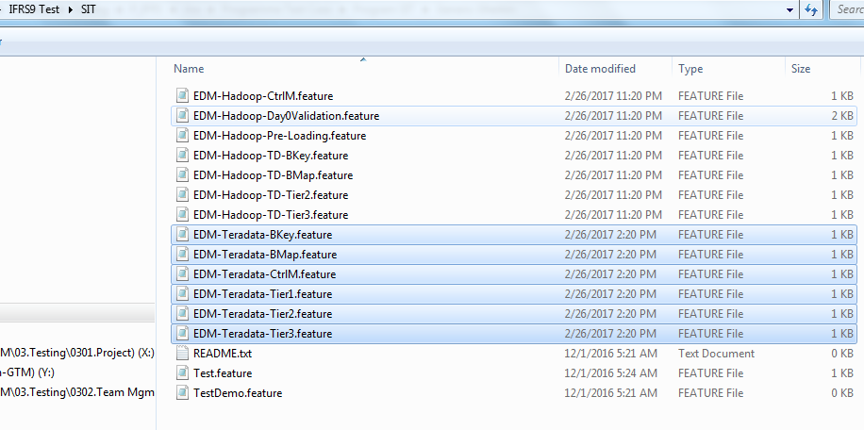

1. At the GIT GUI, click “Rescan” button
2. Any changes your local will shown on the top left corner (Unstage Changes)

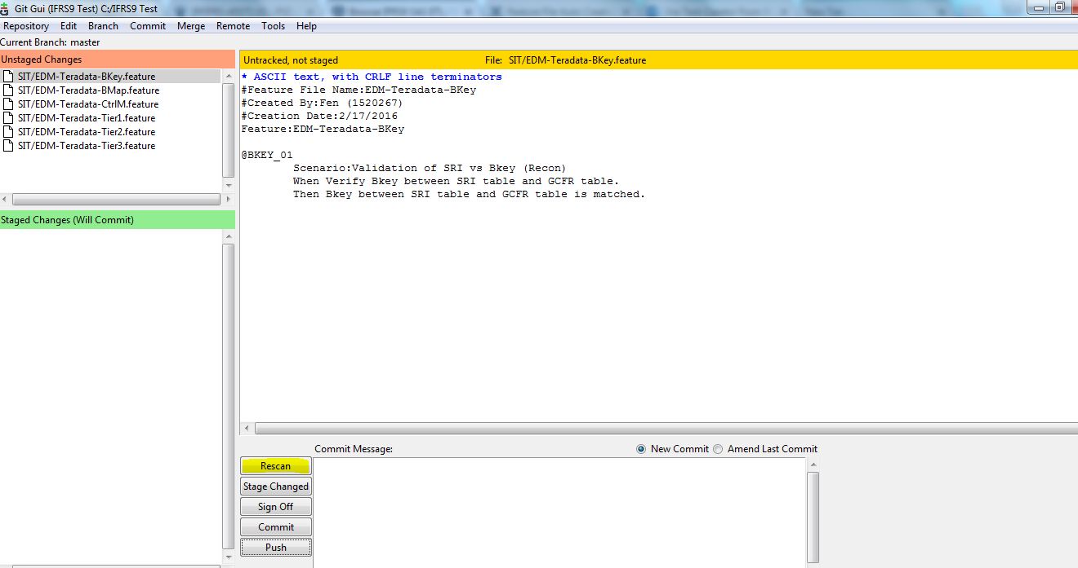

1. Select one of the feature files. Feature files to be commit one by one, this is to make sure the commit message is enter with the corresponding JIRA Task ID ( TE created in Section B.6)
2. Commit -> Stage To Commit

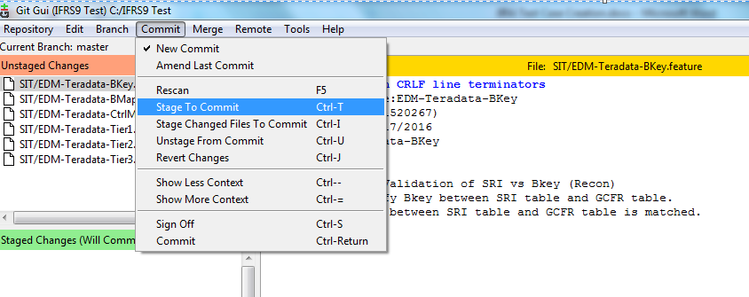

1. Enter the JIRA TE ID in the “Commit Message”.

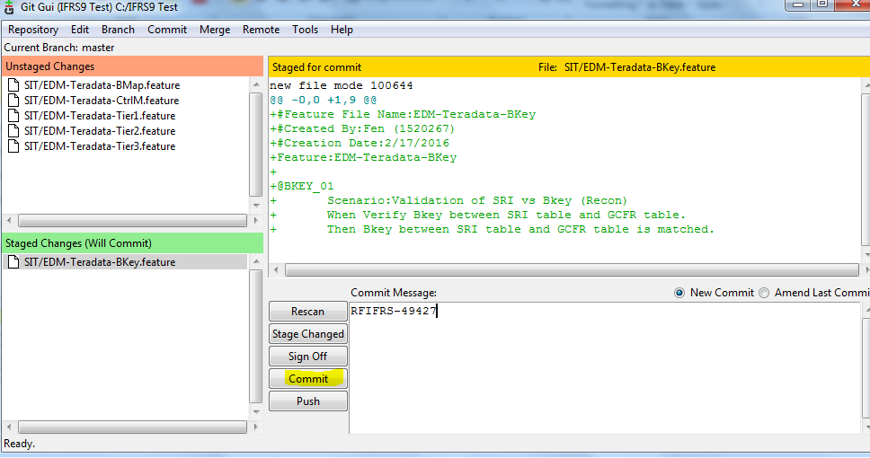

1. Click Commit.
2. Repeat the same for the rest of the files ( item 12 -> item 15 )
3. Commit only commit the changes to the local. To upload the changes, need to push to the server.
4. Click “Push”. Screen below will be prompt. Continue click “Push” and enter password.

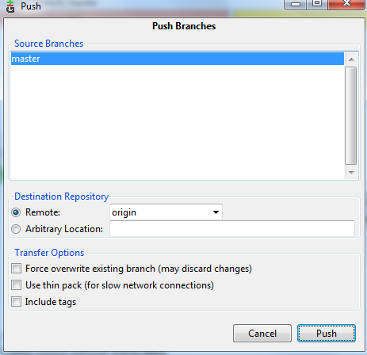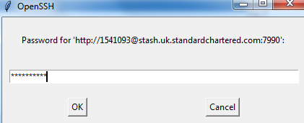

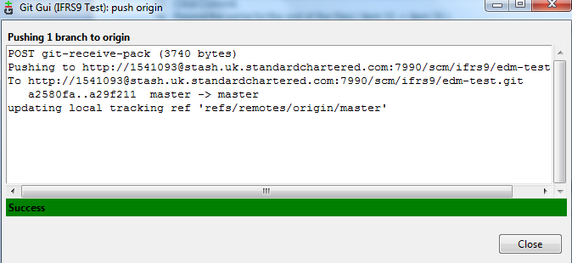

1. Check the Repository. The feature files are successfully uploaded to the server.

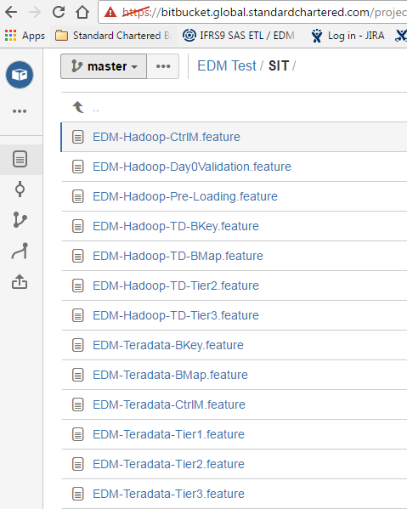

1. **Link Feature File to JIRA Task**
2. Go to the JIRA Task. Click More-> Link

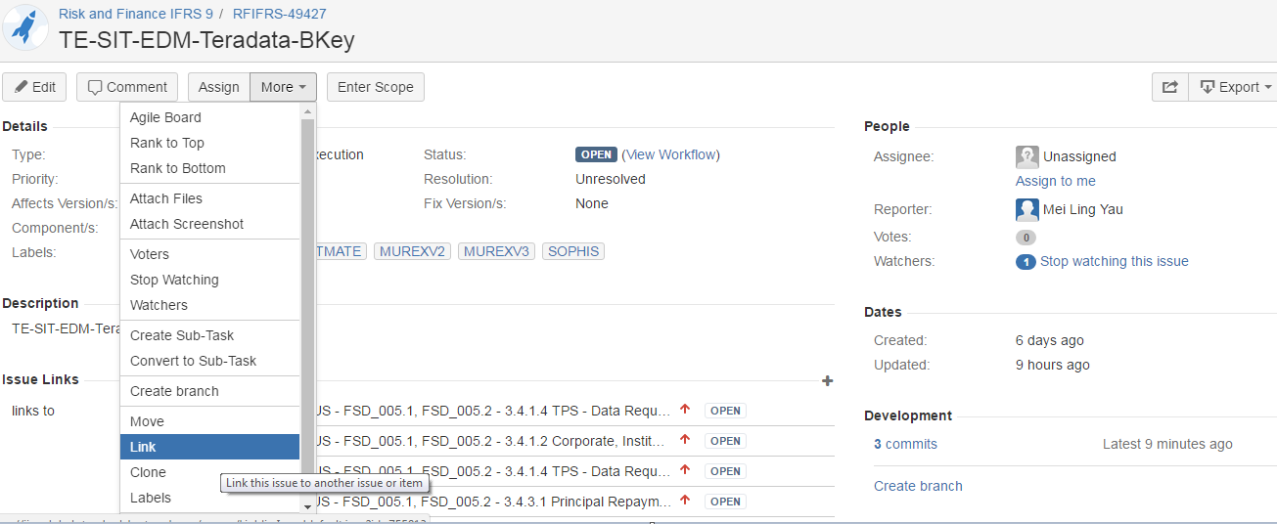

1. Enter the URL of the Feature file in Stash.
2. Enter the Link Text= feature file name.

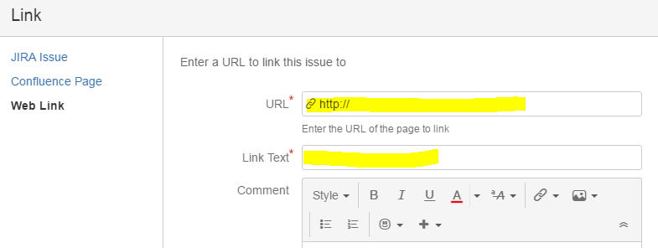

1. Get the URL of the feature file:

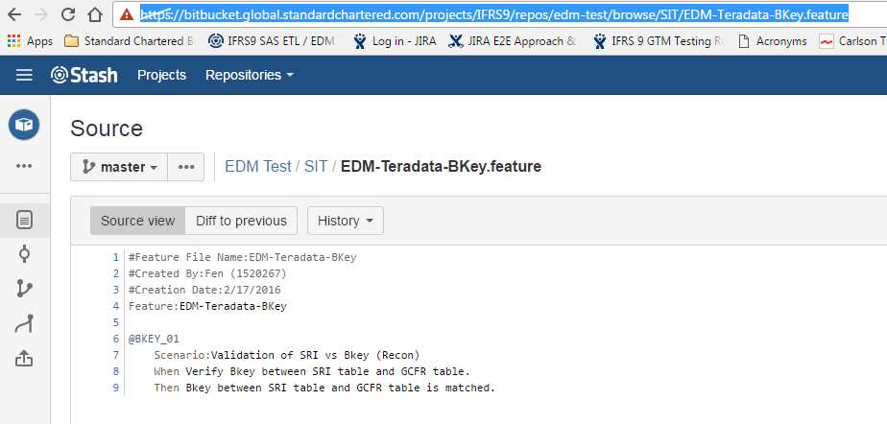

1. Enter in JIRA Web Link, click “Link”.

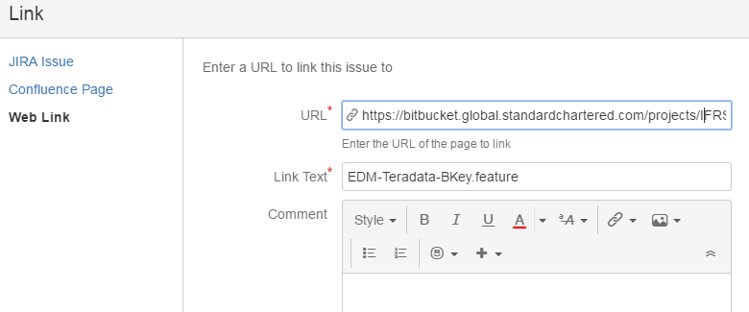

1. TE is link with the Feature file in Stash Repository.

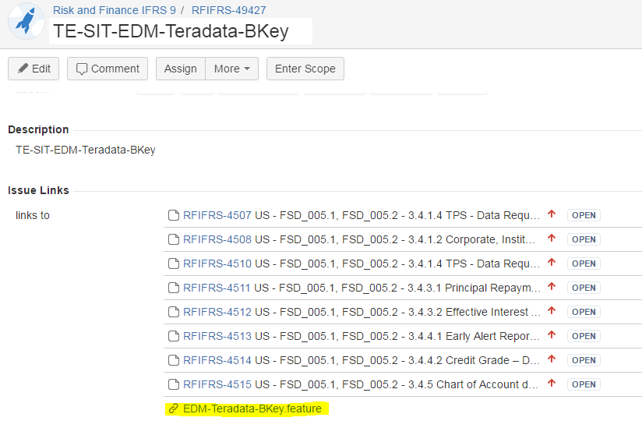

1. **Update JIRA TASK**
2. JIRA Task required to update the Component, Label and User Story (if there are more than 1 user story link to the task)
3. This required to be done manually
4. Based on the Traceability Matrix, identify the source system, and user story for the TE task.

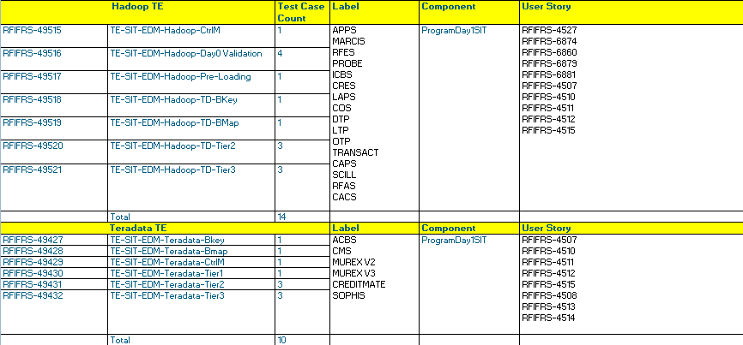

1. Based on the Traceability Matrix, identify the source system, and user story for the TE task.
2. Go to the JIRA Task, click “Edit”:
   1. Component = ProgramDay1SIT
   2. Labels = This TE will be used to test for which source system.
   3. Link Issues = links to : Enter the User Story ID that are not yet link to this TE.
   4. Click “Update”.

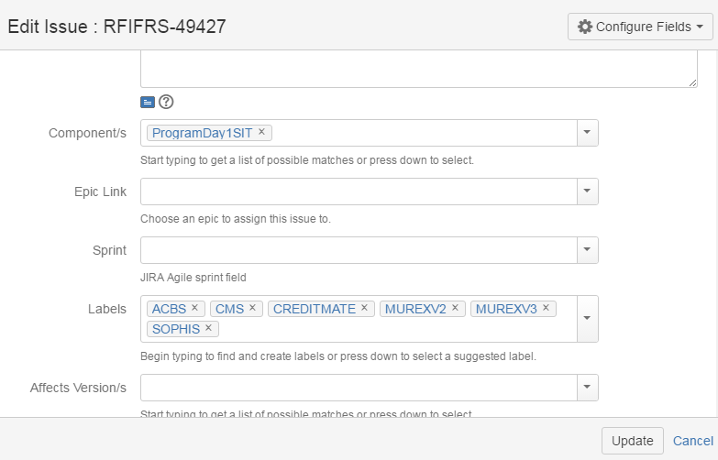

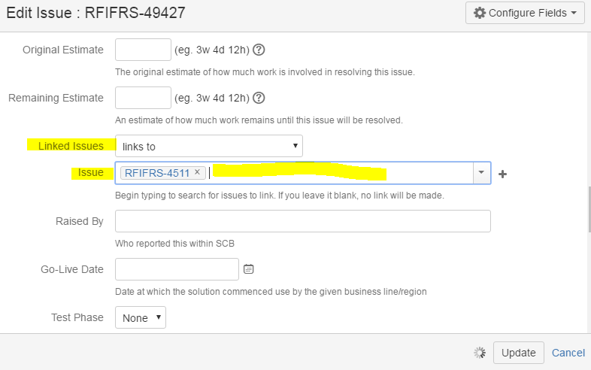

**Appendix:**

* 1. **GIT GUI / GIT CMD**
     1. Subsequent open to GIT GUI:
        1. Open Existing Repository
        2. Direct open form the “Open Recent Repository:”

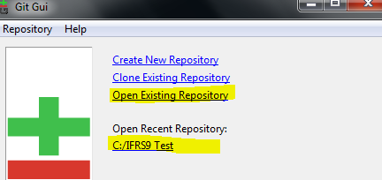

* + 1. Always get the latest changes from the server before any upload or commit.
    2. Remote -> Fetch from -> Origin

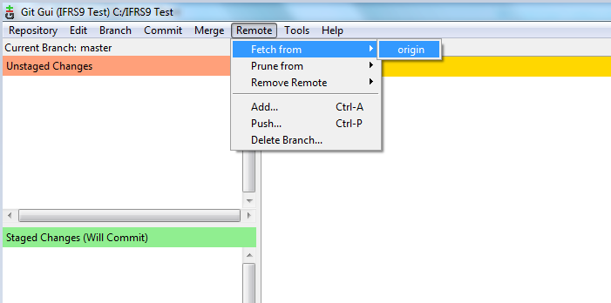

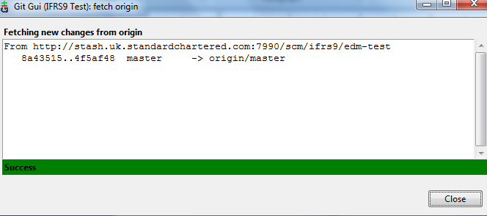

* 1. In case of there are no updates using “GIT GUI” but you notice there are changes in the server, you may use “GIT CMD” to pull the files to the local. Command always works fine.
     1. Open “GIT CMD”
     2. Change directory to your local
     3. git pull origin master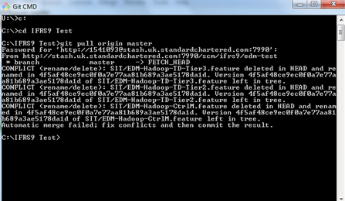

Attached here is more command that can be used in GIT CMD:

